**ALGORITHM TO AVOID THE DANGER**

|  |  |  |  |
| --- | --- | --- | --- |
| Sara Quintero V  Universidad Eafit  Colombia  ssquinterv@eafit.edu. co | Ricardo Gandica  Universidad Eafit  Colombia  Email at Eafit | Andrea Serna Universidad Eafit Colombia asernac1@eafit.edu.co | Mauricio Toro  Universidad Eafit  Colombia  mtorobe@eafit.edu.co |

# **ABSTRACT**

Street harassment is a reality that we all had to experiment at least one time in our lives, it’s an uncomfortable situation that usually women live on daily basis, the terms refers to all kind of words and action that people makes in the streets to people for reason of gender or sexuality, and the importance comes with the fact that is a day to day problem, finding a way to avoid this type of harassment would increase the confidence and security that women have at the moment they step a foot on the streets.

What is the algorithm you have proposed to solve the problem? What quantitative results have you obtained? What are the conclusions of this work? The abstract should be **at most 200 words**. (*In this semester, you should summarize here the execution times, and the results obtained with the three paths*).

## **Key words**

|  |
| --- |
| Shortest route, street sexual harassment, identification of safe routes, crime prevention |

# **1. INTRODUCTION**

The problematic makes it obvious that the need for an alternative choice that doesn’t only consider the shortest route is for certain, women have to live with the sense of danger in every corner that they turn, even in some occasions makes for women and excruciating task having to go outside and makes them live with a recurrent fear, thinking that maybe something bad can happen at all times; having in mind that we currently don’t have a choice that makes this considerations at the time of making routes, it is clear that an alternative should be made.

# **1.1. The problem**

To calculate different paths that reduce both the distance, and the risk of street sexual harassment is a very useful solution because people can search in the option that accords within the need, if it’s needed to arrive on a short period, or in the other hand to choose the safest and possibly shortest route to take.

**1.2 Solution**

The foreseen solution that we propose for the problematic is a software that is capable of finding shortest path between two points of the city, while having also other factors that determine the value of risk of being harassed, and with both parameters makes the most optimal route that guides to the destiny.

**1.3 Structure of the article**

Next, in Section 2, we present work related to the problem. Then, in Section 3, we present the datasets and methods used in this research. In Section 4, we present the algorithm design. Then, in Section 5, we present the results. Finally, in Section 6, we discuss the results and propose some directions for future work.

**2. RELATED WORK**

## Below, we explain four works related to finding ways to prevent street sexual harassment and crime in general.

## *.*

## **2.1 A data integration and analysis system for safe route planning1**

By asking in a one to one survey, the conditions and situations that would make them consider whether they are safe or not, and considering factors that may affect directly or indirectly in their decision, this research came up with a list of influences that play a significant role on the decision:

1. No. of cases in the area
2. People in the area
3. Police stations
4. Illumination
5. Network speed
6. Literacy and unemployment
7. Monetary status
8. Weather conditions
9. Holydays
10. Cameras in the area
11. Sound

## **2.2 Prevent sexual harassment using nearby search2**

In this work, we have the idea of using a heatmap for the visualization of the areas of higher danger. On this heatmap the points that are in red, or orange are points to avoid, it’s a cool idea and it’s very easy to understand, also show at the person in the App easy ways to arrive to hospitals, the App uses the heatmap to Compute the risk associated with taking each route and finding the safest using the analysis, all this to prevent sexual harassment cases

## **2.3 Beyond the shortest route: a survey on quality-aware route navigation for pedestrians3**

On this present work, we have a definition for a particular type of navigation that may result useful for the problem given at hand; Quality aware route navigation for pedestrians, which are systems that provide the pedestrians the ability to move between two points, but give follow primary wishes regarding the preference of the user, which could be between an utilitarian point like the cost of travelling, or the enjoyment and positive experience based on the characteristic of the route like the general appeal of the zone, and lastly, the safety and well-being like crime rates, accidents or pollution.

## **2.4 Route-the safe: a robust model for safest route prediction using crime and accidental data4**

Here we are presented with the idea of dividing a city in smaller regions by applying nested clustering on the data, and giving an score to the selected route based on the clusters and the final route is the one with the lowest risk score

## **3. MATERIALS AND METHODS**

In this section, we explain how the data were collected and processed, and then different alternative path algorithms that reduce both the distance and the risk of sexual street harassment.

## **3.1 Data collection and processing**

The map of Medellín was obtained from *Open Street Maps* (OSM)[1]  and downloaded using the Python API[2] OSMnx. The map includes (1) the length of each segment, in meters; (2) the indication of whether the segment is one-way or not, and (3) the known binary representations of the geometries obtained from the metadata provided by OSM.

For this project, a linear combination (LC) was calculated that captures the maximum variance between (i) the fraction of households that feel insecure and (ii) the fraction of households with incomes below one minimum wage. These data were obtained from the 2017 Medellín quality of life survey. The CL was normalized, using the maximum and minimum, to obtain values between 0 and 1. The CL was obtained using principal components analysis. The risk of harassment is defined as one minus the normalized CL. Figure 1 presents the calculated risk of bullying. The map is available on GitHub[3] .

**Figure 1.** Risk of sexual harassment calculated as a linear combination of the fraction of households that feel unsafe and the fraction of households with income below one minimum wage, obtained from the 2017 Medellín Quality of Life Survey.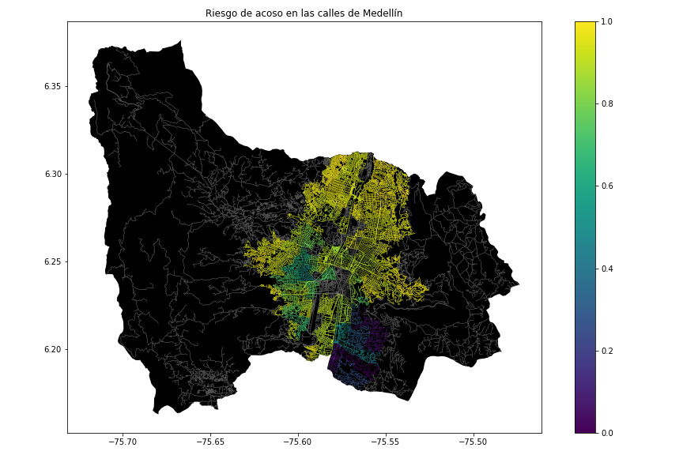

## **3.2 Algorithmic alternatives that reduce the risk of sexual street harassment and distance**

## In the following, we present different algorithms used for a path that reduces both street sexual harassment and distance*.*

**3.2.1 A\***

Please explain the algorithm, its complexity and include your own vector figure designed at https://www.lucidchart.com/ or equivalent.

A* algorithm

**3.2.2 Dijkstra**

Please explain the algorithm, its complexity and include your own vector figure designed at https://www.lucidchart.com/ or equivalent.

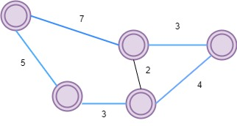

Dijkstra

**3.2.3 Breadth first search Algorithm**

Please explain the algorithm, its complexity and include your own vector figure designed at https://www.lucidchart.com/ or equivalent.

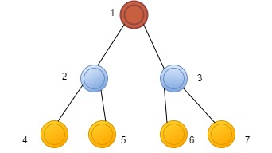

**3.2.4 Depth first search Algorithm:**

Please explain the algorithm, its complexity and include your own vector figure designed at https://www.lucidchart.com/ or equivalent.

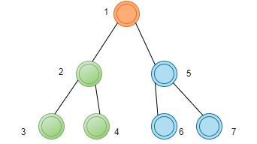

## **4. ALGORITHM DESIGN AND IMPLEMENTATION**

## In the following, we explain the data structures and algorithms used in this work. The implementations of the data structures and algorithms are available on Github[4] .

## **4.1 Data Structures**

## We used the adjacency list using a dictionary to make the map of Medellín. The data structure is presented in Figure 2.

1. b)

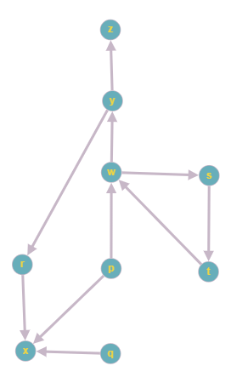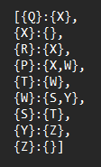

**Figure 2:** An example street map is presented in (a) and its representation as an adjacency list in a dictionary in (b).

**4.2 Algorithms**

In this paper, we propose an algorithm for a path that minimizes both the distance and the risk of street sexual harassment.

**4.2.1 Algorithm for a pedestrian path that reduces both distance and risk of sexual street harassment**

We chose the A* algorithm, because it does the addition or accumulation of distances since the initial point until the destination , and besides it calculates the heuristics which in our case is the risk of possible harassment in a street, the premise of the algorithm is “Best-First”, according to this premise it prioritizes the order of the route, by giving priority to those routes that have lower values of the calculated V variable (d + 100r)

The algorithm is exemplified in Figure 3.

**Figure 3:** Calculation of a path that reduces both distance and risk of harassment 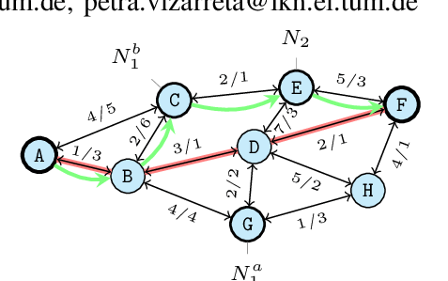

**4.2.2 Calculation of two other paths to reduce both the distance and the risk of sexual street harassment**

Explain the other two paths that reduce both distance and risk of street sexual harassment and make your own graph. Do not use graphs from the Internet, make your own. *(In this semester, the algorithm could be DFS, BFS, Dijkstra, A*, among others).* ) The algorithm is exemplified in Figure 4.

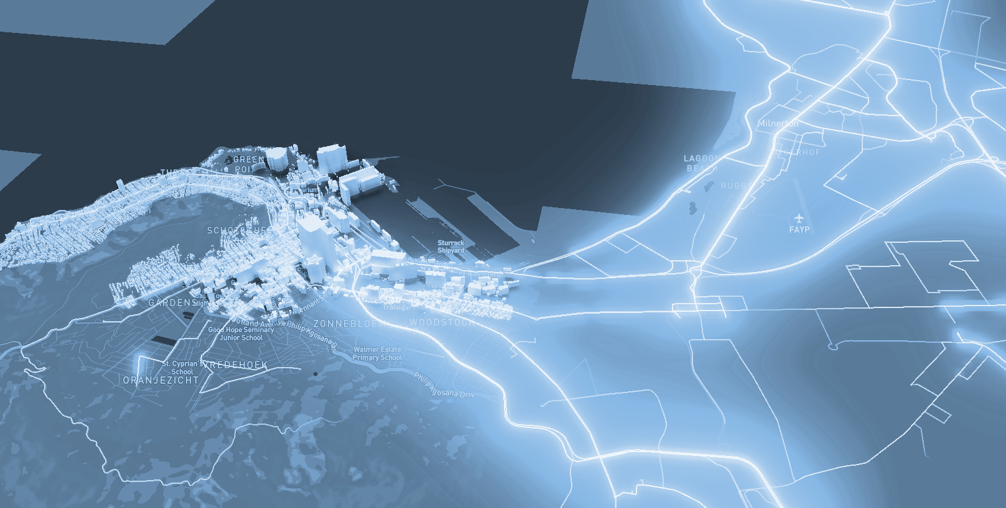

**Figure 4:** Map of the city of Medellín showing three pedestrian paths that reduce both the risk of sexual harassment and the distance in meters between the EAFIT University and the National University.

**4.3 Algorithm complexity analysis**

Explain, in your own words, the analysis, for the worst case, using the notation O. How did you calculate these complexities? Explain briefly.

|  |  |
| --- | --- |
| **Algorithm** | **Time complexity** |
| Algorithm name | O(V2 *E2 ) |
| Name of the second algorithm (in case you have tried two) | O(E3 *V*2V ) |

**Table 1:** Time complexity of the name of your algorithm, where V is.... E is... *(Please explain what V and E mean in this problem). No, do not use 'n'.*

|  |  |
| --- | --- |
| **Data Structure** | **Complexity of memory** |
| Name of the data structure | O(V*E*2E  ) |
| Name of the second data structure (in case you have tried two) | O(2E* 2V ) |

**Table 2:** Memory complexity of the data structure name used by your algorithm, where V is.... E is... *(Please explain what V and E mean in this problem). No, don't use 'n'. That is, don't use 'n'. Not 'n'.*

**4.4 Algorithm design criteria**

Explain why the algorithm was designed that way. Use objective criteria. Objective criteria are based on efficiency, which is measured in terms of time and memory. Examples of NON-objective criteria are: "I was sick", "it was the first data structure I found on the Internet", "I did it the last day before the deadline", "it's easier", etc. Remember: This is 40% of the project grade.

**5. RESULTS**

In this section, we present some quantitative results on the three pathways that reduce both the distance and the risk of sexual street harassment.

**5.1 Results of the paths that reduces both distance and risk of sexual street harassment**

Next, we present the results obtained from *three paths that reduce both distance and harassment,* in Table 3.

|  |  |  |  |
| --- | --- | --- | --- |
| **Origin** | **Destination** | **Distance** | **Risk** |
| Eafit | Unal | ?? | ?? |
| Eafit | Unal | ??? | ?? |
| Eafit | Unal | ?? | ?? |

Distance in meters and risk of sexual street harassment (between 0 and 1) to walk from EAFIT University to the National University.

**5.2 Algorithm execution times**

In Table 4, we explain the ratio of the average execution times of the queries presented in Table 3.

Calculate the execution time for the queries presented in Table 3.

## 

|  |  |
| --- | --- |
| **Calculation of v** | **Average run times (s)** |
| v = ?? | 100000.2 s |
| v = ?? | 800000.1 s |
| v = ?? | 8450000 s |

## **Table 4:** *Algorithm* name execution times *(Please write the name of the algorithm, e.g. DFS, BFS, A*)* for each of the three calculator paths between EAFIT and Universidad Nacional.

## **6. CONCLUSIONS**

Explain the results obtained. Are the paths significantly different? How useful is this for the city? Are the runtimes reasonable to use this implementation in a real situation? Which path would you recommend for a mobile or web application?

**6.1 Future work**

Answer, what would you like to improve in the future? How would you like to improve your algorithm and its application? Will you continue this project working on optimization? Statistics? Web development? Machine learning? Virtual reality? How?

# **ACKNOWLEDGEMENTS**

Identify the type of thank you you wish to write: to a person or to an institution. Keep the following guidelines in mind: 1. The professor's name is not mentioned because he or she is an author. 2. You should not mention the authors of articles that you have not contacted. 3. You should mention students, teachers of other courses who have helped you.

By way of example: This research has been supported/partially supported by [Name of Foundation, Donor].

We are grateful for help with [particular technique, methodology] to [First name Last name, position, name of institution] for comments that greatly improved this manuscript.

The authors thank Professor Juan Carlos Duque, Universidad EAFIT, for providing the data from the 2017 Medellín Quality of Life Survey, processed in a *Shapefile*.

# **REFERENCES**

1. Aryan Guptaa, Bhavye Khetan, "A Data Integration and Analysis System for Safe Route Planning", International Journal of Science and Research (IJSR), Volume 9 Issue 10, October 2020, pp. 1034-1042, <https://www.ijsr.net/get_abstract.php?paper_id=SR201015234344>
2. Omdena | Building AI Solutions for Real-World Problems. 2022. Preventing Sexual Harassment Through a Path Finding Algorithm Using Nearby Search. [online] Available at: <https://omdena.com/blog/path-finding-algorithm/> [Accessed 25 August 2022].
3. Siriaraya, Panote & Wang, Yuanyuan & Zhang, Yihong & Wakamiya, Shoko & Jeszenszky, Péter & Kawai, Yukiko & Jatowt, Adam. (2020). Beyond the Shortest Route: A Survey on Quality-Aware Route Navigation for Pedestrians. IEEE Access. PP. 1-1. 10.1109/ACCESS.2020.3011924.
4. Soni, Shivangi & Gauri Shankar, Venkatesh & Sandeep, Chaurasia. (2019). Route-The Safe: A Robust Model for Safest Route Prediction Using Crime and Accidental Data. 28. 1415-1428.

1. <https://www.openstreetmap.org/>
2. https://osmnx.readthedocs.io/
3. https://github.com/mauriciotoro/ST0245Eafit/tree/master/proyecto/Datasets
4. <https://github.com/GatosLoco1990/sexual_harassment_project>